Fizično računalništvo pri pouku fizike

Učitelji fizike pri svojem delu rokujemo s senzorji in z napravami, s katerimi učencem predstavljamo učinke fizikalnih pojavov. Uporabo senzorike ter načine delovanja največkrat zamolčimo in se osredotočamo na rezultate eksperimentov. Z moderno digitalno tehnologijo postajajo možnosti izdelave merilnikov tako preproste, da jih učenci pri pouku zmorejo izdelati sami.
S projektnim učnim delom smo pouk fizike povezali s poukom informatike. Dijaki so si merilne naprave za merjenje temperature izdelali z mikrokrmilnikom (micro:bit). Svoje merilnike so nato aktivno preizkušali in ugotovili odstopanja od realne temperature. Po tem, ko smo se pogovorili o napakah in delovanju merilnika, so dijaki ob pomoči učitelja poiskali rešitev problema in merilnik nadgradili s kalibracijo. Dijaki so ugotovili, da je temperatura prostora višja od pričakovane, kar so potrdili z meritvijo s klasičnim termometrom. Zaradi tega so merilnik nadgradili s spremenljivko, ki je omogočila popravek pri zapisovanju temperature.
Uporaba fizičnega računalništva je za motivacijo dijakov zaželena, saj dijake usmeri k takojšnjemu odgovoru in takojšnjim povratnim informacijam pri uporabi naprave. Hkrati dijaki s svojim tempom rešujejo probleme, za katere niso niti vedeli, da obstajajo, kar zviša njihovo kreativnost in reševanje problemov v situaciji.
Aktivnosti, ki so potekale pri učni uri, bova predstavila z zornega kota učitelja fizike in učitelja informatike. Pripravila sva tudi učno gradivo, ki bo v pomoč kolegom, ki nameravajo skupaj z dijaki ustvarjati podobne MINUT projekte.
Najina izkušnja potrjuje, da sodelovanje med učiteljem fizike in informatike omogoča, da dijaki pridobijo znanja na drugačen in trajen način. Konkretno reševanje problemov daje namreč trajnostna znanja, ki se prenašajo tudi na druga področja. Tako fizika kot informatika sta predstavljeni na privlačen in uporaben način, dijaki pa na ta način, zraven drugih, razvijajo tudi svoje digitalne kompetence in vidijo prednosti uporabe le-teh.
»Znanost je močna, a je močnejša, ko jo združimo s kreativnostjo.«

Physical computing in physics classes

Abstract
In our work, physics teachers often use sensors and devices to present the effects of physical phenomena to students. The use of sensors and methods of operation are usually not revealed since we mostly focus on the results of experiments. With modern digital technology, the options for making gauges are becoming so simple that students can make them themselves in class.
The physics lesson and the computer science lesson were connected through project-based learning. The students made their own measuring devices to measure temperature with a microcontroller (micro:bit). They actively tested their devices. They figured out that there was a deviation from the real temperature. After talking about errors and the operation of the devices, the students, with the help of the teacher, found a solution to the problem and upgraded their devices by calibrating them. The students realized that the room temperature was higher than expected, which they confirmed by measuring the temperature with a classic thermometer. For this reason, the device was upgraded with a variable that allowed correction when recording the temperature.
The use of physical computing is desirable for student motivation, as it directs students to immediate response and immediate feedback when using the device. At the same time, students solve problems at their own pace that they didn't even know they were present, which increases their creativity and problem-solving skills in the given situation.
The activities that took place during the lesson will be presented from the perspective of a physics teacher and a computer science teacher. We have also prepared teaching material that will help colleagues who plan to create similar STEAM projects together with their students.
The experience we have had confirms that cooperation between a physics and a computer science teacher enables students to acquire knowledge in a different and long-lasting way. Problem-solving tasks provide students with sustainable knowledge that can be transferred to other subjects as well. Both physics and computer science are presented in an attractive and useful way. With such tasks students develop their digital competences and see the advantages of using them as well.

Ključne besede
fizično računalništvo – programiranje – meritve – digitalne kompetence – trajno znanje

Key words
physical computing – programming – measurements - digital competencies – long-lasting knowledge

Roman Bobnarič, prof.
Lenka Keček Vaupotič, univ. dipl. inž.

Slike – so priloga v mapi, tukaj objavljene informativno
Roman Bobnarič: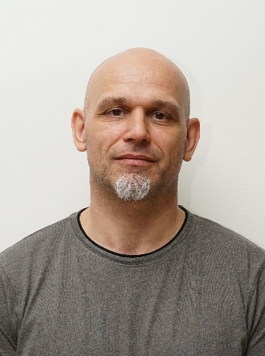
Lenka Keček Vaupotič: 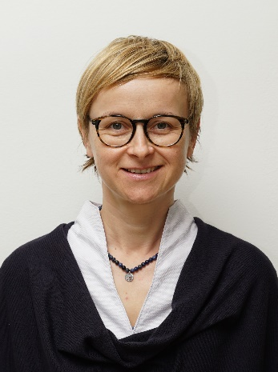
Logotipi za uporabo ob objavi
Gimnazija Ormož: 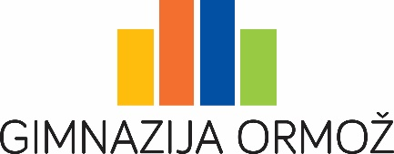
Projekt Minut/NAPOJ: 