OPIS PROJEKTA ZA UČITELJA
Cameleon z Arduino nano

Problem: model, ki prikazuje delovanje obrambnega mehanizma kameleona
Predhodno znanje: učenci poznajo osnove dleovanje arduina, prav tako so že posamično spoznali delovanje Led diode in RGB color sensor.

Modulacija: 3D model s terarijem, osvetljevanje terarija z led diodo.
Izdelati 3D risbo v SketchUp po videovodiču ali le tega prenesti s spletne strani thingiverse (https://www.thingiverse.com/thing:628911)
Enostavneje bi lahko kameleona izdelali 2D s pomočjo šeleshamerja.
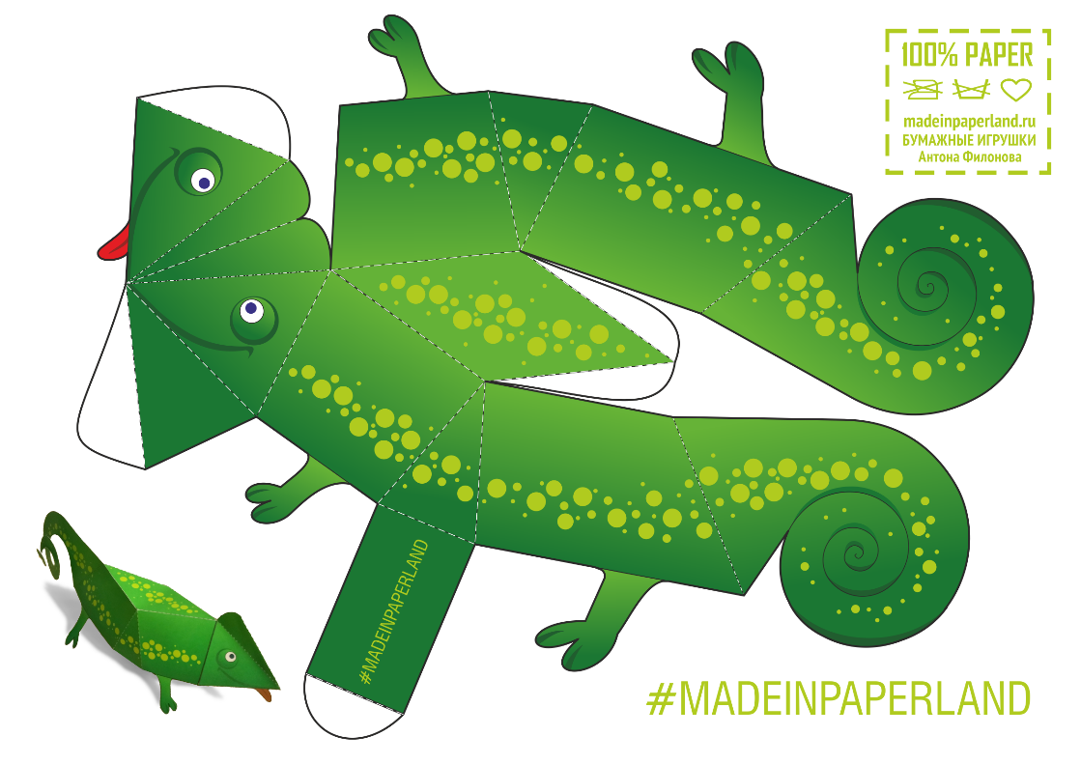

Načrt bi bilo potrebno natisniti v svetlejšo sivi barvi.
Sledi 3D tisk kameleona s tiskanjem, kjer je potrebno nastaviti debelejšo debelino zunanje plasti. Notranjost kameleona naj bo votla.
Zatem je potrebno izdelati ohišje terarija z vejico.

Sledi naj sestavljanje vezja po načrtu s spletne strani.

Algoritem:
Ponavljajoče prižiganje Led diode v naključnih osnovnih barvah (modra, rdeča, zelena, rumena) za nekaj sekund (3-4 sekund) in prižiganje Led diode na kameleonu s pomočjo podatkov z barvnega senzorja.

Program:
// EDISON SCIENCE CORNER //
// EDISON SCIENCE CORNER //
// EDISON SCIENCE CORNER //
// EDISON SCIENCE CORNER //
const int s0 = 8;
const int s1 = 9;
const int s2 = 12;
const int s3 = 11;
const int out = 10;
// LED pins connected to Arduino
int redLed = 2;
int greenLed = 3;
int blueLed = 4;
// Variables
int red = 0;
int green = 0;
int blue = 0;
void setup()
{
Serial.begin(9600);
pinMode(s0, OUTPUT);
pinMode(s1, OUTPUT);
pinMode(s2, OUTPUT);
pinMode(s3, OUTPUT);
pinMode(out, INPUT);
pinMode(redLed, OUTPUT);
pinMode(greenLed, OUTPUT);
pinMode(blueLed, OUTPUT);
digitalWrite(s0, HIGH);
digitalWrite(s1, HIGH);
}
void loop()
{
color();
Serial.print("Red:");
Serial.print(red, DEC);
Serial.print(" Greeen: ");
Serial.print(green, DEC);
Serial.print(" Blue : ");
Serial.print(blue, DEC);
Serial.println();
if ((red < blue&&green)&&(red<30) )
{
Serial.println(" - (Red Color)");
digitalWrite(redLed, HIGH); // Turn RED LED ON
digitalWrite(greenLed, LOW);
digitalWrite(blueLed, LOW);
}
if ((blue <red&&green)&&(blue<30))
{
Serial.println(" - (Blue Color)");
digitalWrite(redLed, LOW);
digitalWrite(greenLed, LOW);
digitalWrite(blueLed, HIGH); // Turn BLUE LED ON
}
if ((red<10)&&(green&&blue<20))
{
Serial.println(" - (yelllow Color)");
digitalWrite(redLed, HIGH);
digitalWrite(greenLed,HIGH);
digitalWrite(blueLed,LOW); // Turn YELLOW LED ON
}
if ((green<red&&blue)&&(green<30))
{
Serial.println(" - (Green Color)");
digitalWrite(redLed, LOW);
digitalWrite(greenLed, HIGH); // Turn GREEN LED ON
digitalWrite(blueLed, LOW);
}
if (red&&green&&blue>50){
Serial.println("no colour");
}
delay(300);
digitalWrite(redLed, LOW);
digitalWrite(greenLed, LOW);
digitalWrite(blueLed, LOW);
}
void color()
{
digitalWrite(s2, LOW);
digitalWrite(s3, LOW);
//count OUT, pRed, RED
red = pulseIn(out, digitalRead(out) == HIGH ? LOW : HIGH);
digitalWrite(s3, HIGH);
//count OUT, pBLUE, BLUE
blue = pulseIn(out, digitalRead(out) == HIGH ? LOW : HIGH);
digitalWrite(s2, HIGH);
//count OUT, pGreen, GREEN
green = pulseIn(out, digitalRead(out) == HIGH ? LOW : HIGH);
}

