IT competences assessment through ICT escape room

Bojan Musil*, Smiljana Gartner**, Igor Pesek***, Marjan Krašna****
*University of Maribor, Faculty of Arts, Department of Psychology, Maribor, Slovenia
**University of Maribor, Faculty of Arts, Department of Philosophy, Maribor, Slovenia
***University of Maribor, Faculty of Natural Science and Mathematics, Department of Mathematics and Computer Science, Maribor, Slovenia
****University of Maribor, Faculty of Arts, Department of Pedagogy, Maribor, Slovenia
bojan.musil@um.si, smiljana.gartner@um.si, igor.pesek@um.si, marjan.krasna@um.si

Abstract - To assess the ICT competences most frequently tests or work assignments are used. Tests are more reliable because they are conducted in the controlled environment, but they are also time limited and stressful and consequently not entirely encouraging surrounding for competences’ assessment. Work assignments are usually more time consuming, done outside the controlled environment, hence less reliable. Initial intention of our team was to prepare alternative type of tests of the IT competences using the concept of escape rooms. In our experiment, person or two cooperate solving IT problems to gain "freedom" at the end, i.e. to unlock the escape room. In this environment, the stress is inherent but with fun components. Participants do not feel the context as a test environment and the stress of failure is less evident. Each participant in the experiment can learn his or her IT weak points. It takes around one hour to find the way out of the room and another half for discussion. Participants are asked to complete the survey before the entrance into the IT escape room and this survey is later used in the discussion, which is the base for the qualitative analysis. One of the conclusions from our analysis is that it is not easy to prepare the suitable assignments and clues to solve them. Additionally, we discovered that there are problems of understanding of the IT terminology hence the help clues, which are perfectly understandable to the IT specialist, are generally not suitable for experiment’s participants.
Keywords: Education, IT, Competences, Assessment, Escape room

Introduction
We can observe in Slovenia and other EU countries that use of ICT in education lacks behind the use of ICT among the general population. What we have observed in the past few decades, and consider it as transient phenomenon, have become an undeniable fact. Teachers report that despite kids have ICT equipment they do not use it for the educational purposes. There are two possible reasons for this:
- they do not know how to use it or/and
- schools do not have resources (tools nor knowledge).
It is even worst; schools have ICT equipment, but it is rarely used. Available ICT equipment is not enough; competent teacher should be the one to use ICT equipment effective and didactically suitable. The odd thing is that even after extensive training [1] teachers’ behavior did not change significantly. Teachers show they are capable to use the ICT equipment on the training but not in the classroom. Between 2017 and 2018 Ministry of Education funded a project where all Slovenian teacher training study programs participated [2] and where current study was conducted.
We started researching the competences in education in 2008 with the project “Development of natural science competences” [3]. Since then we develop and test procedures further; we gained significant insight into competence assessment; but we still lack the reliability of the competence assessment. We can prepare the test to grade the knowledge or skills, but competences are still more or less soft assessed and influenced by observer or individual who performs self-assessment. In the past years, we have cooperated with the colleagues from natural science department who addressed the problem of use of ICT in education and study different outcomes. They focused on the use of ICT in lab work and the influence of ICT used in education to the students of educational study programs. [4] [5] [6] [7] [8]; and use of ICT as simulation tools to gather the insight to the natural phenomena that are hard to analyze during the experimental exercises (lab work) [9].
One relatively new method of educational gaming involves adapting the popular entertainment activity of the “escape room”. Escape rooms are “live-action team-based games where players discover clues, solve puzzles, and accomplish tasks in one or more rooms in order to accomplish a specific goal (usually escaping from the room) in a limited amount of time.” [10]. Educational escape rooms generally operate in the same manner, but the clues, puzzles, and solutions pertain to specific learning objectives. From an instructional standpoint, escape room games are collaborative, task-centered, time-based, and provide immediate feedback, which make them an attractive consideration for in-class learning activities [11].
We wanted to make informal test where participants would be intrinsically motivated, where they would feel the need to find the solution of problems based on the clues. Such environment would be much more suitable for competence assessment than assignment where individual just follow predefined sets of action and solve the problem. With this in mind, we have decided to design an ICT escape room and test it among our colleagues and students.

ICT escape room design
In the design of the ICT escape room, we wanted to design tasks that are common in the classroom where ICT is available. We have analyzed the most common problems teachers experience in the classrooms. We have verified the selected topics with school ICT professionals. In the ICT assignments, we have prepared the scenario, which would lead the participants to the final task – finding the key to get out of the room. Our goal was to include hardware, software, and communication topics. In our scenario most of the participants would get to the end, though they find different routes through our ICT maze. Time requirement for participants to solve all different puzzles in the ICT escape room should be 45 minutes, however it generally required a little more time. One hour solving time was our limit and then we stopped the processes. On Figure 1 we present outline of our scenario with tasks and riddles that participants had to solve it.

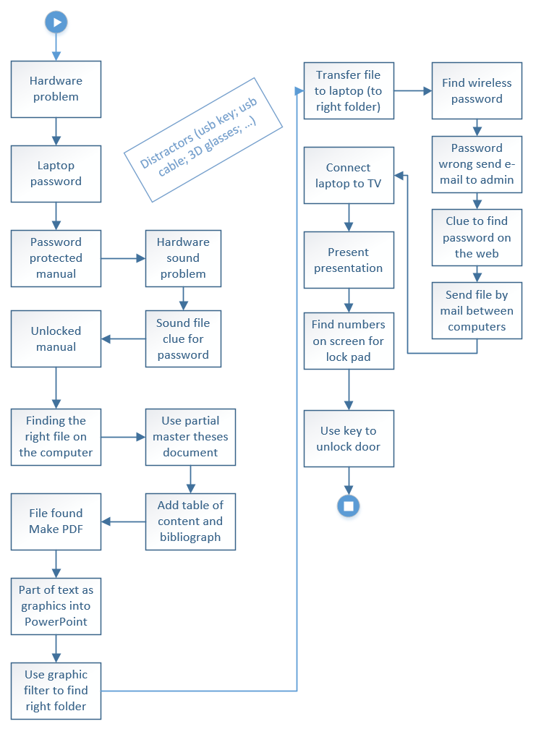
Figure 1: Graphics scenario for ICT escape room
ICT escape room does not need big space; small corner in the classroom is enough, as shown on Figure 2. We designed the room to be very similar to the usual setting in the classroom. There are two computers, one stationary PC and one laptop. PC has connection to the internet using Ethernet cable but no wireless capability. Laptop on other hand has disabled Ethernet port and it is not connected to the internet but has wireless capability. There is also wireless router on the table and around the computer corner there are scattered some objects (on the wall; on computer screen; in the name of the files …) with previously mentioned clues and distractors (3D glasses, broken USB key, etc.) that are there to confuse participants but don’t have any role in the scenario.
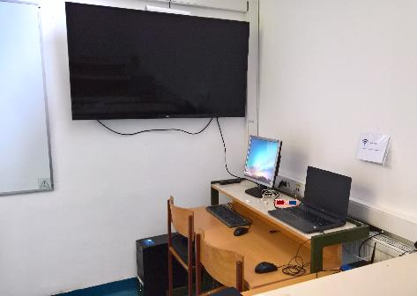
Figure 2: A 3m x 3m setting is enough to prepare ICT escape room
Clues can be found around the setting as well on the computers, participants just need to look carefully. Two clues are presented on Figure 3.
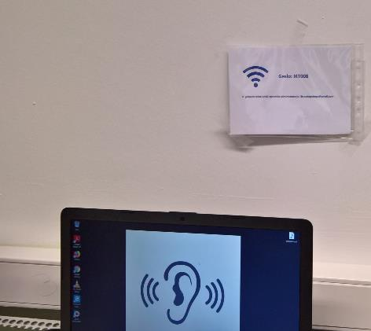
Figure 3: Different clues are displayed around the working area
Next, we describe different topics that we included in our ICT escape room.

Background story for the ICT escape room design
Every escape room needs a background story, which gives context. Participant(s) (up to three) who enter the ICT escape room get the initial story that gives him or them a clue how to start. During the process of solving the puzzles in the ICT escape-room, new stories with the clues are uncovered. Uncovering new clues determine the stages where the participant(s) are in the scenario (see Figure 1).

Hardware topics
Most common problems that teachers encounter in the classrooms are related to the power plugs. We have prepared the computer and unplugged it from the power line (as students sometimes do to teachers). The first task that the participants need to solve is to find the power cord and plug it to the stationary computer to power it up.
Powering the laptop up, the second problem arises; the laptop is protected with the password. In general, this is the situation in most of the classrooms and the password is somewhere to be found. In our case, the password for laptop is displayed on the background image of the stationary computer. If participant wants to enter arbitrary password on the laptop, the hint points him to the stationary computer.
At the end of scenario, we have additional hardware task where participants need to connect laptop to the TV and set up the projection.

Software topics
Software topics are divided into the two subtopics. One requires setting up computer and the other is office tools oriented. In the setting up participants are required to find password for password-protected file. On the laptop the speakers are turned to low volume and sound files default open setting is set to open sound files with wrong program.
Office tools phase consists of more tasks, find right file to open in word processing application, where they need to prepare:
- table of content and
- insert bibliography and
- count words in document;
- convert the text to pdf,
- capture screen of the pdf file and
- insert the captured image into presentation application on specific slide in the background of all other objects on this slide.

Communication topics
At the beginning, only the stationary computer has internet access. To find the key of the room the participants need to transfer file from stationary computer to the laptop. There are different clues on how to setup connection on the laptop. Automatic mail response system from system administrator gives clue where to find wireless password. To make system more realistic the Ethernet (wired) connection on the laptop is disabled. This often happens when user does not have administrative privileges on the computer where they supposed to have presentation. Provided USB key is intentionally broken, therefore, they need to find the way to transfer file from one computer to another using email or any other means (file transfer, Dropbox, etc.).

Help clues
The participants may ask for help if they feel incapable to find a solution. However, we provide help on our own if we see that participants are stuck in the perpetual loop. We have prepared help in different parts of the process and are generally in the form - read text carefully; examine something; see what is written somewhere...

Competences and ICT escape room
In the beginning of the ICT escape room design, we knew that practical constraint would limit us in the testing of the potential competences. Searching the solid background for ICT competences, we decided to use DigComp 2.1: The Digital Competence Framework for Citizens [12]. On the other hand, we wanted to test competences needed in the most common ICT situations that can occur in the classroom. Time constraints and practical value of the ICT escape room prevented us to test all competences and levels from DigComp 2.1. In general, our competence test covers all 5 topics:
- Competence area 1: information and data literacy;
- Competence area 2: communication and collaboration;
- Competence area 3: digital content creation;
- Competence area 4: safety;
- Competence area 5: problem solving
According to the DigComp 2.1 we could test previously mentioned competences on eight proficiency levels, but it could not be done within the desired time constraints.

Analysis
In the context of the analysis and evaluation of the ICT escape room we included 24 subjects who volunteered to participate in the initial or upgraded scenario version of the ICT escape room. The participants were between 17 and 53 years old, (M = 33.83; SD = 9.87), half of them being males (50.0 %). In the first scenario version (the initial phase), three advanced ICT users participated in the single-user context. In the second scenario version (the upgraded phase), 21 participants with various levels of ICT expertise participated in the group context. The objective of the initial phase was to gain the first insights into the ICT escape room dynamics, concretely, to test the separate segments of the scenario and possibly to improve them. The objective of the upgraded phase was to gain as much as possible feedback information from the users in the fixed scenario context of the ICT escape room. In both phases participants at the beginning, i. e. before entering the room, filled short evaluation questionnaire concerning some basic information about respondents’ ICT use, attitudes towards ICT and self-evaluation of ICT competencies (some of the scales were adapted and elaborated from the instruments in [13] [14] [15];. Then they entered the ICT escape room. After finishing the ICT escape room, test subjects participated in the short (evaluation) interview and filled the questionnaire with the self-evaluation of ICT competencies again. The dynamics in the ICT escape room was monitored by two to three observers who intervened in the process in the case of explicit demand for help of the participants or in the case of the perpetual loop of the participants. In the upgraded phase, the observers also used short screening scheme of the ICT escape room scenario to gain approximate information about the duration of separate segments, the order of the segments, number of potential clues, and evaluation of the performance of separate segments in the scenario. With the strict consent of the participants (those who signed the informed consent form), the dynamics in the ICT escape room was recorded on camera for the analysis and evaluation purpose only.
In the initial phase, three males participated who were above intermediate or advanced ICT literate. The process in the ICT escape room lasted from 38 to 50 minutes (45 minutes in average), with several interventions (clues) mostly regarding the text in the instructions and segments in the scenario related to content creation in the office tools environment. All participants in this phase evaluated their experience in the ICT escape room as positive. Based on the observation of the process in the ICT escape room and feedback information in this phase we made some changes. We slightly modified the instructions and clues for the average ICT user who have problems with the proper understanding of ICT terms to better understand what he/she needs to do but we did not make any drastic intervention into the initial scenario. The difference between the version of the ICT escape room scenario in the initial phase and the version of the scenario in the upgraded phase was thus marginal. The outcome of the initial phase was elaborated and finalized scenario, tested in the next phase of analysis and evaluation.
The analysis and evaluation in the upgraded phase were more thorough and exact since we had a fixed scenario of the ICT escape room and screening scheme. Also, potentially we gained more information since the participants worked in a group of two (dyads) and in one session in a group of three.
On average the session lasted approximately 54 minutes (range from the app. 39 to the app. 64 minutes), with one dyad not resolving the scenario in one hour and an additional extra five minutes.
There was variability in a number of help clues, ranging from 1 to 25, with median 5.
From the perspective of the segments in the scenario, the steps from hardware problem to finding the right file on the computer, addressing the digital competency of (ICT) problem solving, lasted app. 8 minutes (range from 4 to 13 minutes).
The steps from use partial master theses document to use graphic filter to find right folder, addressing the digital competency of digital content creation, lasted app. 27 minutes (range from 12 to 40 minutes)
The steps from transfer file to laptop (to right folder), to transfer file between computers, addressing digital competencies of communication and collaboration and information and data literacy, lasted approx. 11 minutes (range from 7 to 16 minutes).
The most time consuming were steps addressing digital content creation (in office tools environment). This phase also required the most help clues from the observers and with more moderate estimates of the performance from the perspective of participants.
Generally, the participants evaluated the experience of the ICT escape room positively, with an average of 4.45 on the 5-point scale where 5 is the best score.
In the scale of self-evaluation of ICT competencies, the scores on the 5-point scale before entering the ICT escape room and the scores after the finish in the phase of evaluation were generally comparable. Three exceptions were detected:
- There was a significant difference in the scores for competency of resolving ICT problems before entering the ICT escape room (M=3.23; SD=1.02) and scores after the finish of the ICT escape room (M=3.95; SD=0.90); t(21)=-3.46, p=0.002;
- There was a significant difference in the scores for competency of use of office tools before entering the ICT escape room (M=4.27; SD=0.55) and scores after the finish of the ICT escape room (M=3.73; SD=1.08); t(21)=2.32, p=0.030;
- There was significant difference in the scores for competency of production of project work before entering the ICT escape room (M=4.23; SD=0.75) and scores after the finish of the ICT escape room (M=3.86; SD=0.77); t(21)=2.94, p=0.008.
Participants emphasized as positive the selection and nature of the tasks or problems in the scenario. They have positively related the scenario to the real-life experiences with ICT. The same positive experience was expressed in the context of gaming and pleasure.

The most negative experiences of the participants were related to the (self-)criticism about the text of the instructions; specifically, about their limited concentration regarding the exact content and meaning of the instructions.
The most useful suggestion from the evaluation phase is related to the digital competency of safety. This competence assessment was not initially planned to be in the scenario of the ICT escape room. Since some of the participants mentioned it in the interview, we added the possibility to evaluate this competency to the ICT escape room, and especially in the phase of evaluation of the ICT escape room experience (interview). Thus, it is possible to track personal digital footprints in the context of participants being in the ICT escape room, and in the phase of interview highlighting this important aspect of ICT use.

Conclusion
Competences assessment is not as simple as knowledge assessment. It generally requires assessment of knowledge, (transferable) skills, and (personal) attitude. The ICT is used in everyday life and in the education as well. What is the effective use of ICT in education is a debatable question. Kids often use their ICT gadgets as their body extension for communication and fun. The possession of the ICT gadget does not imply they will be used properly in the education. Teaches need to be ICT competent to teach kids how to use ICT in education. In the course of our project, where we wanted to discover why teachers do not use schools’ available ICT effectively, we have find out various reasons. Even if teachers have successfully completed ICT courses they generally acquire knowledge but not competences to use the knowledge effectively. As one of the way to test the ICT competences in “fun” way we prepared the ICT escape room. Our intention was to get the insight to the ICT competences of most common situation that may occur in the schools’ environment. We prepared the scenario to test hardware, software, and communication skills of the participants. In course of planned 45 minutes the participants solve different ICT problems to find the exit of the ICT escape room. Most participants needed around one hour to complete all required tasks. Analysis has shown that test subjects generally assess their ICT competences higher in some topics which proved them wrong in the ICT escape room. The most significant finding would be:
- People are lazy (superficial) readers
- ICT terms are not properly understood (this is the problem of education)
- Preparing the ICT room is fun but preparing the proper clues (instructions) is much harder task.
- ICT escape room is fun and highly graded among test subjects.

References

[1] | SIO - Slovensko izobraževalno omrežje, “Project E-school (e-šolstvo),” n.d.. [Online]. Available: https://projekt.sio.si/e-solstvo/.
[2] | M. Krašna, D. Korže and B. Kaučič, “Searching for the reasons why ICT is not adequately used in schools,” in MIPRO 2018 : 41st International Convention, Opatia, Croatia, 2018.
[3] | Faculty of Natural Science and Mathematics, “Project Development of Science Competences,” Faculty of Natural Science and Mathematics, 2007-2013. [Online]. Available: http://kompetence.uni-mb.si/. [Accessed 24 2 2019].
[4] | A. Špernjak, M. Puhek and A. Šorgo, “Lower secondary school students' attitudes toward computer-supported laboratory exercises,” International journal: emerging technologies in learning, vol. 5, no. 2, pp. 23-26, 2010.
[5] | A. Špernjak, “Biology students' teacher opinions about the integration of ICT into the learning and teaching process,” Innovative issues and approaches in social sciences, vol. 7, no. 2, pp. 121-134, 2014.
[6] | A. Špernjak, “Computer-supported laboratory as an effective educational tool,” in MIPRO 2011 : 34th International Convention, Opatija, Croatia, 2011.
[7] | A. Špernjak and A. Šorgo, “Differences in acquired knowledge and attitudes achieved with traditional, computer-supported and virtual laboratory biology laboratory exercises,” Journal of Biological Education, vol. 52, no. 2, pp. 206-220, 2018.
[8] | A. Špernjak and A. Šorgo, “Outlines for science digital competence of elementary school students,” in MIPRO 2018 : 41st International Convention, Opatija, Croatia, 2018.
[9] | R. Repnik and V. Grubelnik, “Develpment of natural science and digital competences by using e-learning materilas for third grade of primary-school physics,” in 5th International Technology, Education and Development Conference (INTED), Valencia, Spain, 2011.
[10] | S. Nicholson, “Peeking behind the locked door: A survey of escape room facilities.,” 24 5 2015. [Online]. Available: http://scottnicholson.com/pubs/erfacwhite.pdf. [Accessed 24 2 2019].
[11] | S. Nicholson, “Creating Engaging Escape Rooms for the Classroom,” Childhood Education, vol. 94, no. 1, pp. 44-49, 2018.
[12] | S. Carretero Gomez, R. Vuorikari and P. Yves, “DigComp 2.1: The Digital Competence Framework for Citizens with eight proficiency levels and examples of use,” 2017. [Online]. Available: https://ec.europa.eu/jrc/en/publication/eur-scientific-and-technical-research-reports/digcomp-21-digital-competence-framework-citizens-eight-proficiency-levels-and-examples-use. [Accessed 24 2 2019].
[13] | B. Boh Podgornik, T. Bartol and A. Šorgo, “Test informacijske pismenosti študentov: Projektna dokumentacija v raziskavi J5-5535: Razvijanje informacijske pismenosti študentov v podporo reševanja avtentičnih naravoslovnih problemov,” Naravoslovnotehniška fakulteta, Ljubljana, 2015.
[14] | T. Senica, Pripravljenost učiteljev začetnikov za učinkovito vključevanje informacijsko-komunikacijskih tehnologij v poučevanje (magistrsko delo), Maribor: Univerza v Mariboru, Fakulteta za naravoslovje in matematiko, 2017.
[15] | A. Šorgo, T. Bartol, D. Dolničar and B. Boh Podgornik, “Attributes of digital natives as predictors of information literacy in higher education,” British Journal of Educational Technology, vol. 48, no. 3, pp. 749-767, 2017.

