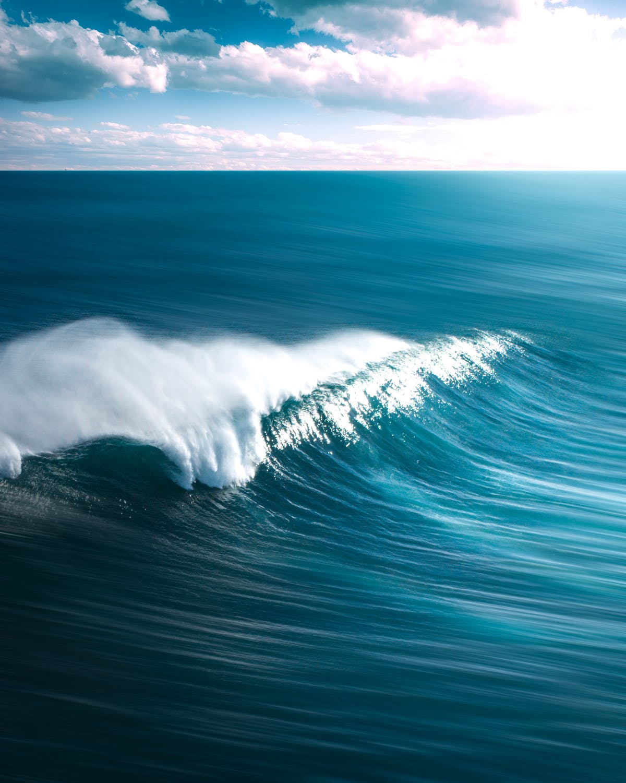Vse najboljše za 37. rojstni dan
Joj, koliko a-jev!

Namig: Geslo je skrito v seznamu naključnih nizov znakov (na naslednji strani). Pravilni niz znakov je tisti, ki je edini dolg neko število znakov. Tako da mu odstraniš vse pojavitve nekega znaka (najpogostejše črke).

ivlqtiaamlieacaaajobaadnaciaaqdqafy
pfzjgpcaagakarjajynaaciyaanfrzadahyy
yvmaaaajalaaodbafhzuordaaaamstceaekaaoj
nfcsiufaaahlahkbgoavnjaaacnawtaaakam
iwmjjscrajamatxolrafaaaaauaxakaxraoaai
gapaasawahaecxakaraaaaaaaxhvakaukibu
ffaaagbcblmliqyoaaataockavkaotiuiy
ebmdabnzmfyfazehlrabykyuaanijebdasa
ochobsaaaaaaafmldoadaafaytuaoffarzyn
ohrlapvaaaarxldymuanaabqapkkaiaysgar
ixvcaxafaagcklaaajaeaaahmraljealpsx
oqciaoaoaiavacaahdaoaaxiaraaaaaqkjwssbb
mnacarcvvxaapwaaamgajxlqfaaatlacab
tvwtccaaabdmajxalatiekviazweoyajvaonak
fjafanaaanfjaxaacmzeaatneoxbawavwsaaat
xcatakqhalaypzaancuvwsanqcuacblaaa
ulvaakxaacumahzlaarmaqmraazufaaqasmkaaa
noriyzahaaayacatbcwfaaptarafaaaoaoaa
jzaeafakaaanaeajamvoeaaiaasvasaavi
aeacasahajajalaizamacaeafaaxamakpaoaa
dtbnaaayeaaraxnaamswaakawvazsuahgiaeala
retuprqjaakcozkradawqmjtaravafajggcoqhs
tselfuappwajagnkhnaoecfaapvualaueokj
jfpfbnhauapmiuagnpalaajlaghdajaterkq
maaylcaiwauaadaarnaranauapanuuahaafasp
kafvauaaabacabqlpfaeaaliaaifafalwuud
ahkxyuaawesaasuawkaraapvawybiatkobvotkk
seaalwfaaxviadccfcaapswtmiahppablmqaahg
ghueaqrztyacqaarkdrvaaajaibaacafanki
ltxcandkqkaajzasanabasaucaaaaakmah
tapcsuaakzcqkanpayagagataaaaaaarqd
bafiauavxoeqaewxalahkanvxauaadstuaa
ppkaaipzwkawaaxlavaiaayaalqjabawga
sqeoaearacakteaamjafkaglakaaaaakgtabfiu
zasaawkzasaaaaxvlzatamtyaprsaaanaa
ciqnagabaaafapvpgloaqosjazazaoanpawm
wakqngaaazasaealaaagackxazruafaikmy
zmahboaaqrpwayshaicxaaalanegangsaabraq
fcvaatoasnimaaeaqazwavaaafvmanadao
mmaukkaazuoaaafssraaaaxhaaxvaxawbqaoasa
hjzakfaasaavaaeajdaarahnavbqfqamps
itaawzvcdsahadaadfbaasemamtjakahtaaaja
efymqaasjsaaaydtaeadzazlaraqkdknaji
ndoadsakaflbauamulaojaxiamxfakjykajayl
baaamvkaaaaaaaucjsfaaasvacarapeusl
tpsaaoadajcaayaafaalxolaeaaaauapabvaaax
xrfaadahanvvadaacavhanmwhqaaapsgvn
qkbaahcarmaxaagaobaraaaaajuampawxevaac
rxaaovachafsaiaaajcaavnvzfsxayihaazfan
mydmaamvmlzhatuamfaxauqeeaapacatczqo
bmacynarrlptaxaatnajagjvgvenaaayha
zalqatbdpfrracxaggaeaaevjzfpzocaaaa
lifuauaaalagadzkahgnfotoawvvakzsvna
naacaacydaaqakakwvaqannjazasazalaaveper
bdtkfsbwaxafaqgoaaaaalbihjtlspawag
mtnaxeicaqaklbvamzawaaaynajartafanaaaab
wzwairhanavxbaalaxxsaaavawsrapasat
uuaaxpaifvaxwisagnalaaqcanknccauiqxaaaa
layaafavawgcaiaaxadmaakmaksbbaamad
hilhaaquwbraahaappfyaaacyadaxkaefbx
hwasdgjzuvajababahaaocydaazaatayaaa
qdaikaaaqvntlmaaahahagehadlazqavaaaa
ijqdvdahvgavyqaqsaakzaniicjonnaaaas
hgaemaapvhquhaiaxsayrqzkamuumnatia
szubaaaiavahaeanalawajcmaqtaadmuadgk
sjadxatnuluvgcpzlawdykcaatcsakabfaaxaga
yaefaaaavaahahxronydauaeawdcabazozaaas
advkapivaarnafakawahayzaawwraiaeaz
oilpawaeaapealpaaaagaawmatkhafaaafvaafm
gvhmahmlkaaziaaaraaudagzazaaanaoaaaaar
lkhgaerctvaspaablaaywrayazhtborhma
dqyduayuaaadaaaaanjkaaxianwaataoiaqjvmf
hcahakotaasrpsavaoafaesdaokiaklzqajocn
idpmtsaaraauacaajxzraaxnoapmawaoala
rjaaapqzvxarluvoqzdxihagaawfaoaeauj
bdayhaavhhlkauawziguxaycqpaayvgqjld
vcsuwaaeasacaobafsilxlqigjonapaaxada
ovqjvrabaoqyawajecazarzvadaaacaazaaoak
seoznawfbufsanaasadtanniahxsfaaksww
xupwjjaaasakmzicixkbgaawuaaaayaeaa
hcaawdpefdamsvbaaxhjaankaaytaaavah
isycdlwjaealaiaqaaaaavldaxaaaykeaaatka
wkaencjfawaganhnoajiaackguapaaaaaaf
szmxmgaaazgxaaaaosawaaarazsjybxgaardaws
hysnaaaacxwxsizazqaaadrbdslabaadta
wgaaccsaansntbhdagdoaalrauakaaahsv
aalaaqlaacsvqinaanaiuaxnaxcuafaaaaasaac
ggladiamasgylcaankamaangutjsaaaqgnqraa
iffqhgwakueaadaaukazaiatakbzacasldaaaa
yhuuacpxwcapavcasuacahaqaafanoaaatja
fvaiayazaaaxaqaaacpadjvsrmaaabsbnxaw
davtaxqmyakoaanaaujocwauaaclkuaeyiataw
mahpaaapazavaulaaaaraaaraswrnjaazb
qspwkqaqithnachzaoaolhowaoaharagtasa
pmzjaaaaadoxalaraaagsarcaircashabjam
togagaahcgazadauaxoxaabtaaaaataaihhtzwa
swdqakaaawmaakluafalafdaaflyajabaaza
swuaiaaaaakztxooeuanrsrdabuviaaeagp
phnbapggauwetzavnaaeaqknauuqaaamptks

