From "Ban It Till We Understand It" to "Resistance is Futile":

Guo, Lau

How are instructors planning to adapt their programming-related courses as more and more students start using AI coding assistance tools such as ChatGPT and GitHub Copilot?
A series of studies throughout 2021 and 2022 showed that GitHub Copilot can solve many kinds of CS1 and CS2 homework problems (see Section 3 of our paper for a summary of these studies). However, Copilot still requires users to install, configure, and activate it within an IDE like Visual Studio Code, which can be hard for novices to do. So when ChatGPT launched at the end of 2022, it made this AI technology far more accessible and easier to use. Now any student can visit the ChatGPT website, copy-paste in their homework assignments and instructor-provided starter code, and watch ChatGPT generate the solutions for them. Given this new reality we're all now living in, Sam and I wanted to know what computing instructors are planning to do to ensure that their students are still learning well.
To gather a diverse sample of perspectives, we interviewed 20 university CS1/CS2 instructors across 9 countries (Australia, Botswana, Canada, Chile, China, Rwanda, Spain, Switzerland, United States) spanning all 6 populated continents. To our knowledge, our paper is the first empirical study to gather instructor perspectives about these AI coding tools that more and more students will likely have access to in the future.
Here's a summary of our findings:
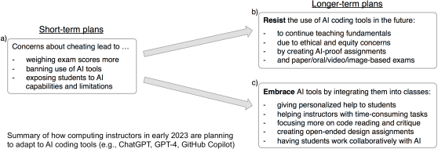
Short-term, many planned to take immediate measures to discourage AI-assisted cheating by weighing exams more, trying to ban these tools, or showing students their limitations. Then opinions diverged sharply about what to do longer-term, with one side wanting to resist AI tools by creating more AI-resistant assignments and exams, and the other side wanting to embrace these tools by integrating them deeply into introductory programming courses.
Our study findings capture a rare snapshot in time in early 2023 as computing instructors are just starting to form opinions about this fast-growing phenomenon but have not yet converged to any consensus about best practices. Using these findings as inspiration, we synthesized a diverse set of open research questions regarding how to develop, deploy, and evaluate AI coding tools for computing education. For instance, what mental models do novices form both about the code that AI generates and about how the AI works to produce that code? And how do those novice mental models compare to experts' mental models of AI code generation? See Section 7 of our paper for more examples.
We hope that these findings, along with our open research questions, can spur conversations in our community about how to work with these tools in effective, equitable, and ethical ways.

